**2016-3-17**

**new approach:**

 in ref [1] p329, which has been used in Bobby’s paper[2]

# Basic equation

The absorption coefficient in unoccupied semiconductor is calculated by:

 (1)







where  is the reduced (or joint) density of states, , [eV·s·cm-1] is the mometum transition matrix element averaged over the solid angle. For spin degeneracy, the above expression for the matrix element assumes that one factor of two will be included in the expression of density of states.

# Technical bottleneck

Before we dive into the detailed calculation, it’s important to pick out the key parameters that affect the end results.

Equation (1) can be rewritten into:

 (2)

Because Ep doesn’t vary much between different binary materiels (22~29), we can further reduce it to:

 (3)

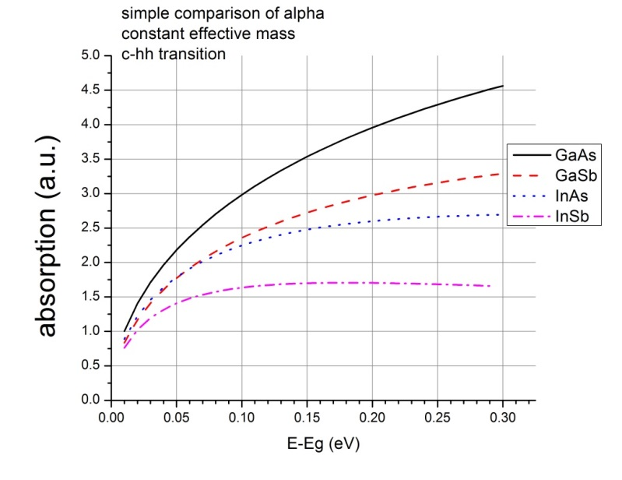 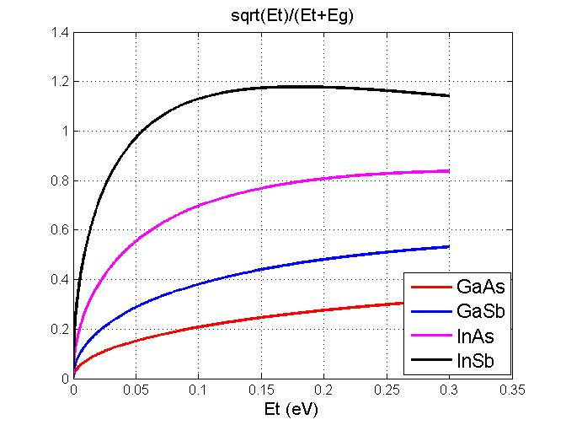

This shows that they are on the same order of magnitude. InAs is no less than half of GaAs.

Effective mass should be treated very carefully if the nonparabolicity is considered.

# Energy dependent effective mass

## 2 band vs 8 band model

The eigen function and solution is:





For convenience in calculation, use 

,

If we use the **new definition**  in ref [1]



which produce a more reasonable effective mass.

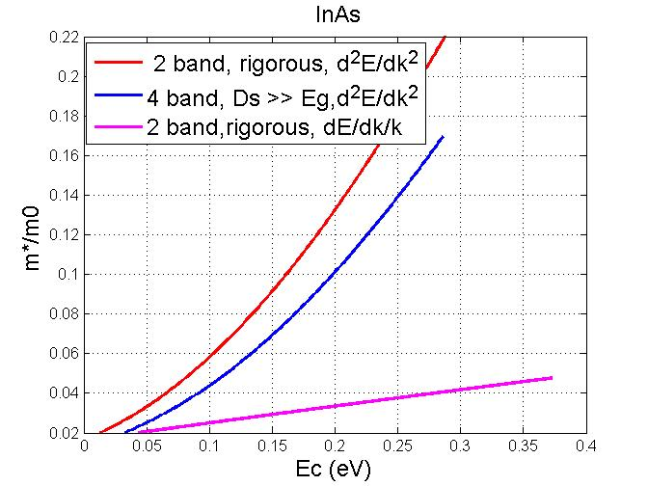 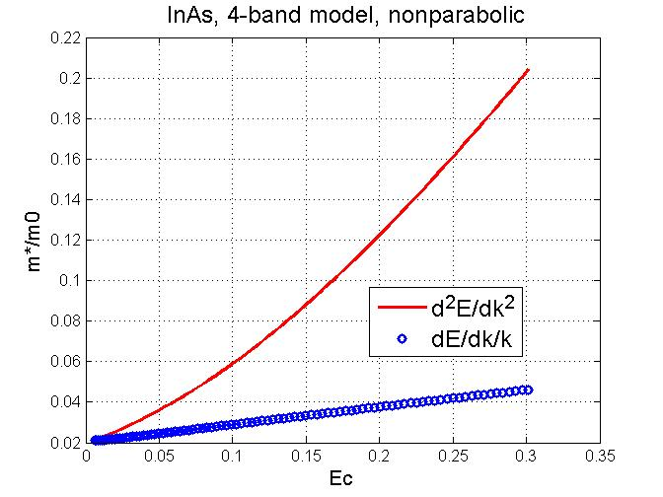

## GaAs bulk

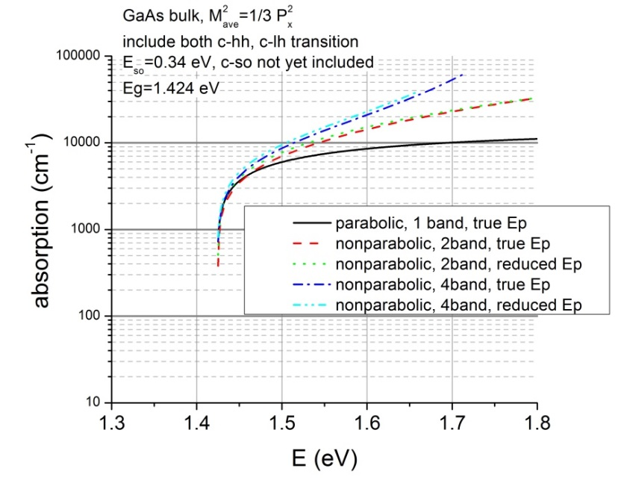 

The reported value is 1e4 /cm at 0.07 eV above bandgap [3]

## InAs bulk,

[4]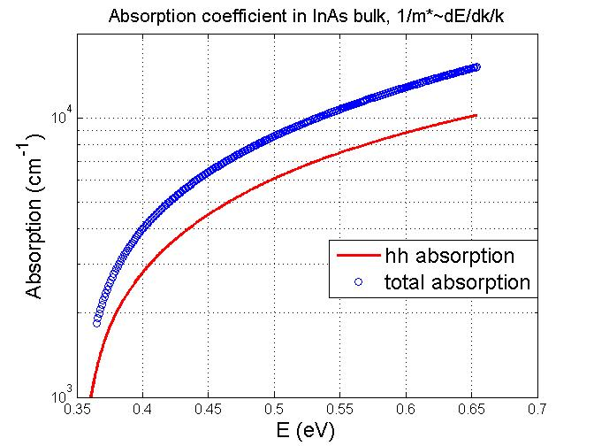

## InSb bulk

[5]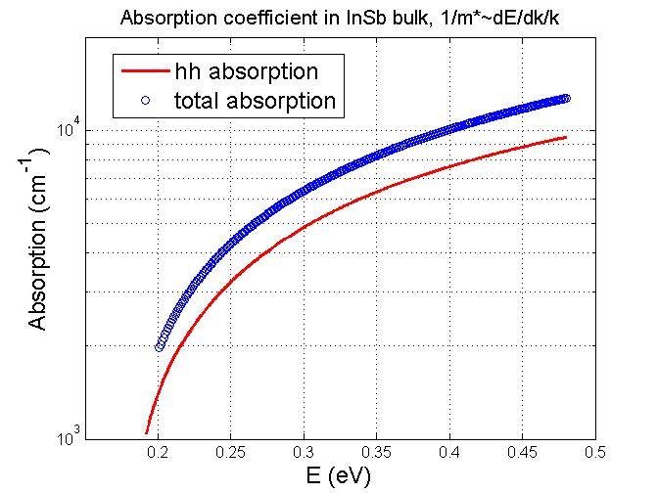

Kane use 8 band model to calculate the fundamental optical absorption

## Ga0.44In0.56As0.5Sb0.5

### bandgap

1. If use a general equation given by [6]:



the ternary material bandgap is obtained by bowing parameter.

The calculated result is 0.4424 eV. this is much larger than the experimental value of 0.3 eV.

2. use lattice matched combination: GaSb+InAsSb

(GaSb)0.44+ (InAs0.91Sb0.09)0.56

Eg(InAs0.91Sb0.09)= 0.09*Eg_InSb+0.91*Eg_InAs-0.09*0.91*0.67=0.2834

Eg(GaInAsSb)= 0.44*Eg_GaSb+0.56*InSbAs-0.44*0.56*0.6**=0.332 eV**,

3. use equation in [7] J. Appl. Phys., **87**, 1780 (2000).

Eg=0.726-0.961*x-0.501*y+0.08*x*y+0.451*x^2+1.2*y^2+0.021*x^2*y-0.62*x*y^2=**0.318**

assume refractive index is energy independent. n(InAs)=3.5; n(GaSb)=3.8; n(InSb)=4.0; n(GaAs)=3.3.

### new attempt

α(GaSb)0.44+ α(InAs0.91Sb0.09)0.56

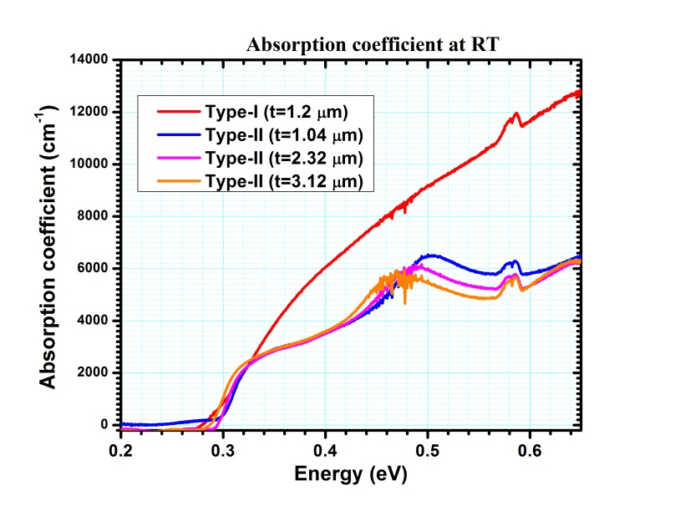 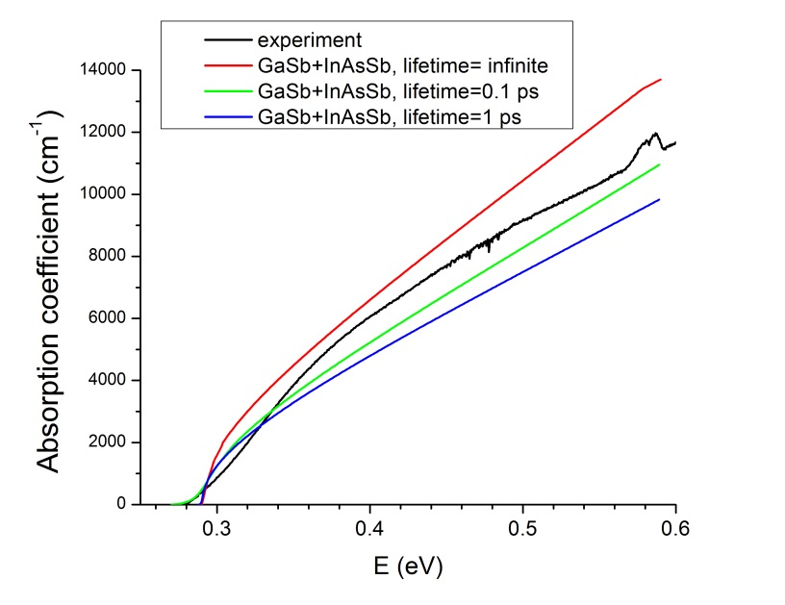

References

[1] P. Yu and M. U. Cardona, *Fundamentals of Semiconductors: Physics and Materials Properties*. (Springer Berlin Heidelberg, 2010).

[2] R. T. Hinkey, Z. Tian, R. Q. Yang, T. D. Mishima, and M. B. Santos, "Reflectance spectrum of plasmon waveguide interband cascade lasers and observation of the Berreman effect", J. Appl. Phys., **110**, 043113 (2011).

[3] H. C. Casey, D. D. Sell, and K. W. Wecht, "Concentration dependence of the absorption coefficient for n− and p−type GaAs between 1.3 and 1.6 eV", J. Appl. Phys., **46**, 250 (1975).

[4] J. R. Dixon and J. M. Ellis, "Optical Properties of n-Type Indium Arsenide in the Fundamental Absorption Edge Region", Phys. Rev., **123**, 1560 (1961).

[5] E. O. Kane, "Band structure of indium antimonide", J. Phys. Chem. Solids, **1**, 249 (1957).

[6] I. Vurgaftman, J. R. Meyer, and L. R. Ram-Mohan, "Band parameters for III--V compound semiconductors and their alloys", J. Appl. Phys., **89**, 5815 (2001).

[7] M. Muñoz, K. Wei, F. H. Pollak, J. L. Freeouf, C. A. Wang, and G. W. Charache, "Optical constants of Ga1−xInxAsySb1−y lattice matched to GaSb (001): Experiment and modeling", J. Appl. Phys., **87**, 1780 (2000).